# Study Watch Firmware Upgrade

This document lists down the steps to do Firmware Upgrade, starting with programming the Watch with bootloader first.

Contents

Study Watch Firmware Upgrade 1

Loading Bootloader onto Watch from SES 2

Loading Bootloader onto Watch from nRF Connect Programmer 4

Bootloader Firmware Upgrade (On a Watch which already has a bootloder) 6

Preparing firmware to be downloaded 8

Firmware Upgrade with USB Transport 9

Firmware Upgrade with BLE Transport 10

Firmware Upgrade from Applications Wavetool 14

## Loading Bootloader onto Watch from SES

1. If the NOR Flash needs to be erased, prior to programming the Watch, following erase command may be used:

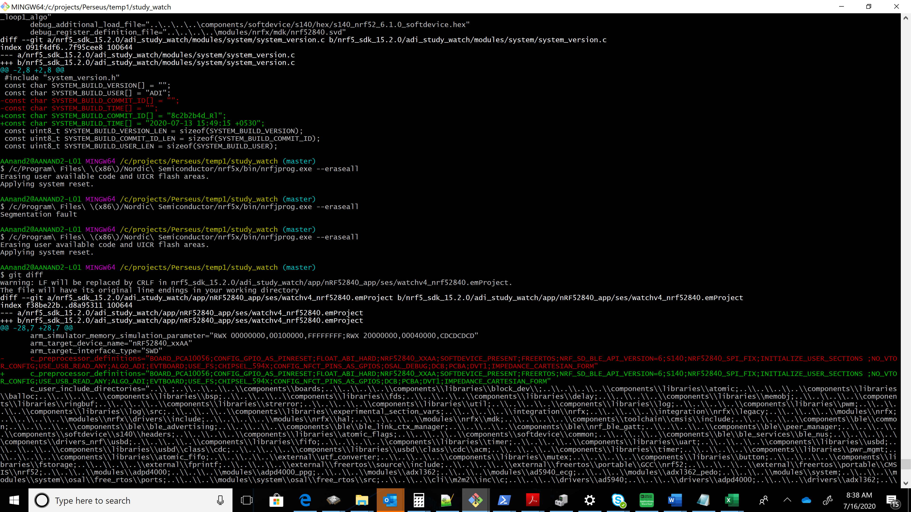

1. Go to latest master branch from study_watch project in bit bucket: [https://bitbucket-ext.analog.com/projects/PERSEUS/repos/study_watch/browse/](https://confluence.analog.com/display/HEALTH/Study+Watch#StudyWatch-Firmwarerepository-https://bitbucket-ext.analog.com/projects/PERSEUS/repos/study_watch/browse/)
2. Open the SES project file from the path "study_watch\nrf5_sdk_15.2.0\adi_study_watch\bootloader\ses\ADI_bootloader.emProject". Compile and download this firmware through J-Link connected to the debug board, which in turn is connected to the Watch as in Figure 1

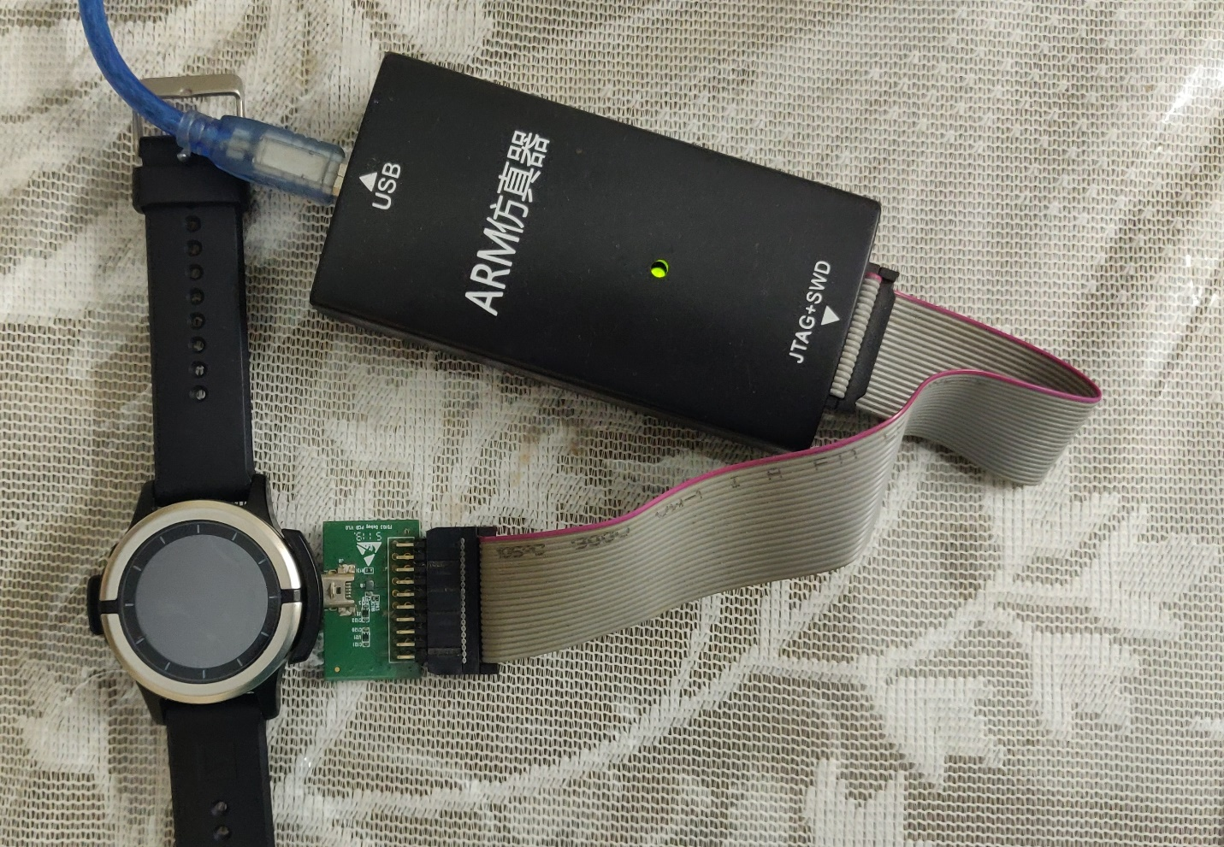

Figure DVT1 Watch connected to debug board & JLink

1. The DVT1 Watch is in bootloader stage now as in Figure 2. On scanning from nRFConnect App you can note that Watch board is listed as “ADI_dfu” device name. Also note down the COM port number of the DVT1 Watch board, after connecting a micro-USB 2.0 cable to the USB connector. If you can’t find this port number, you may need to install the nrfconnect-driver-installer.exe

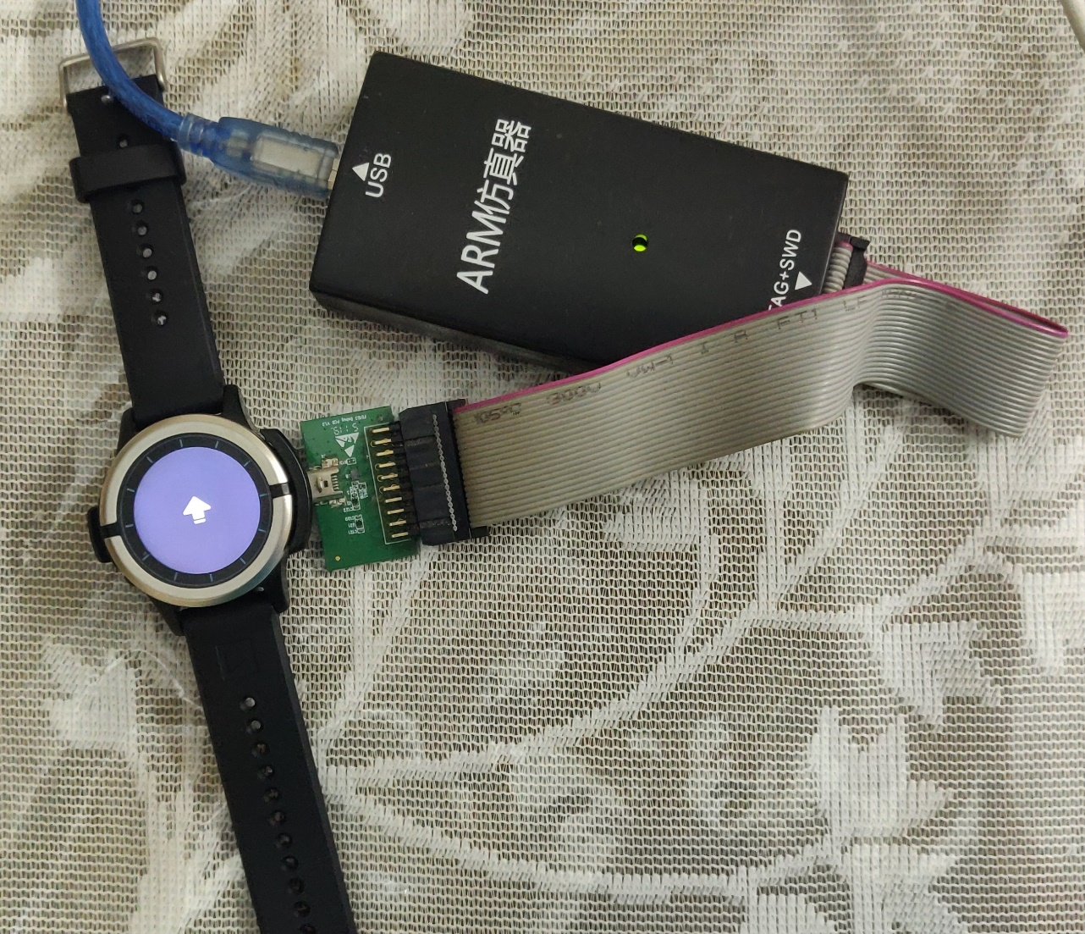

Figure DVT1 Watch board in bootloader mode

## Loading Bootloader onto Watch from nRF Connect Programmer

1. Download the latest nRF Connect Desktop application from [nRF Connect for Desktop - nordicsemi.com](https://www.nordicsemi.com/Software-and-Tools/Development-Tools/nRF-Connect-for-desktop)
2. From this download the nRF Connect Programmer App as shown below:

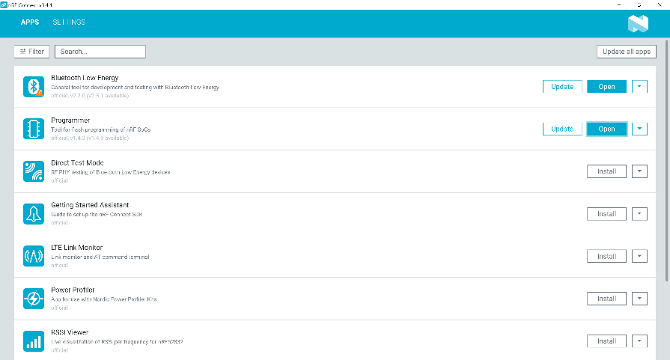

1. Connect the Watch via debug board – Jlink debugger to the PC, as in Figure 1. Open the nRF Connect Programmer.
2. From the top left corner, drop down for “Select Device”, choose the jlink serial number of the Watch to connect to it:

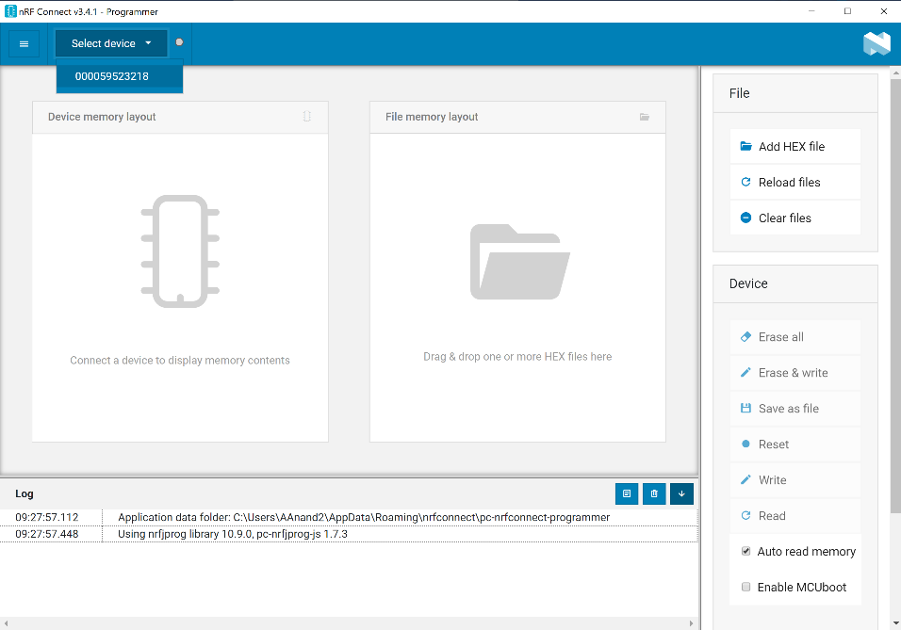

1. Once connected, you can do “Erase all” from the option on the right-side pane:

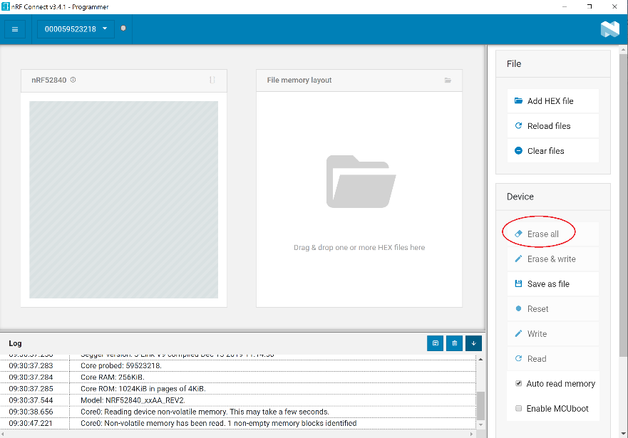

1. Using “Add HEX file” option on the right-side pane, select the softdevice hex file to be loaded:

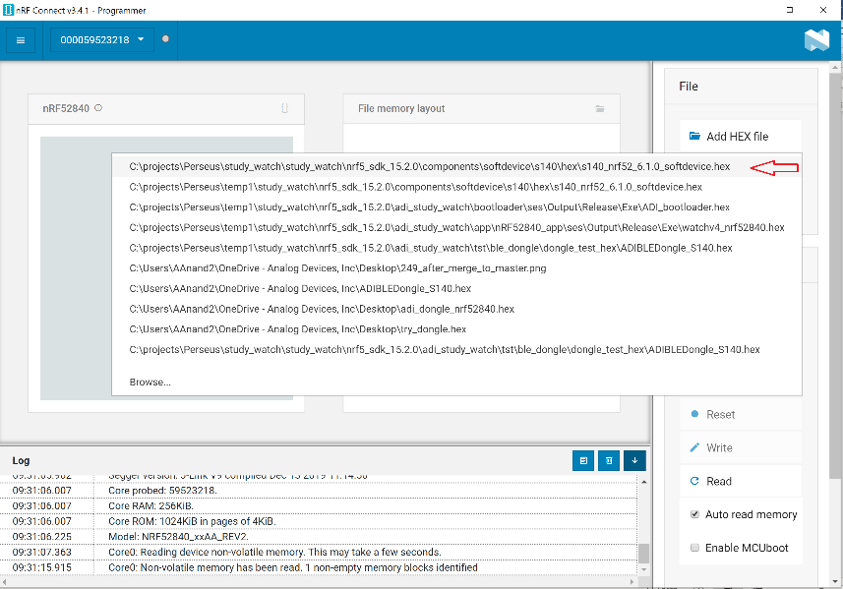

1. Similarly choose the prebuilt bootloader hex file to be loaded:

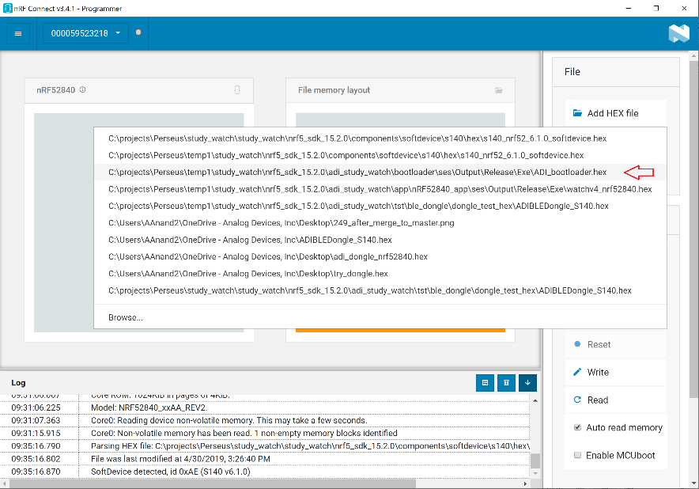

1. Choose “Write” option from left-side pane to download the bootloader on to the Watch:

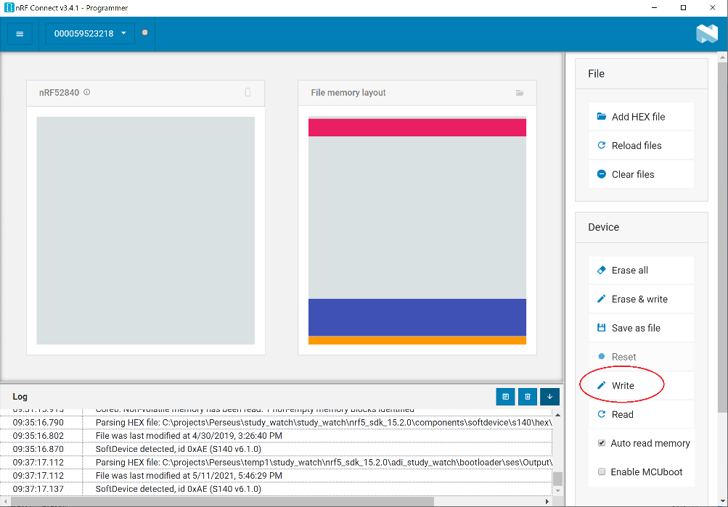

1. Once this is completed, the Watch will come up with bootloader as shown in Figure 2.

Note: this process maybe extended to load the Watch application hex file as well.

## Bootloader Firmware Upgrade (On a Watch which already has a bootloader)

1. Open the SES project file from the path "study_watch\nrf5_sdk_15.2.0\adi_study_watch\bootloader\ses\ADI_bootloader.emProject".
2. Compile and keep the bootloader firmware to be upgraded to.
3. Execute “boot_zip_generate.bat” from the path “study_watch\nrf5_sdk_15.2.0\adi_study_watch\bootloader\boot_zip”. This will generate ADI_bootloader.zip in the end.
4. The content of the batch file is as below. The red marked value is the version of bootloader.

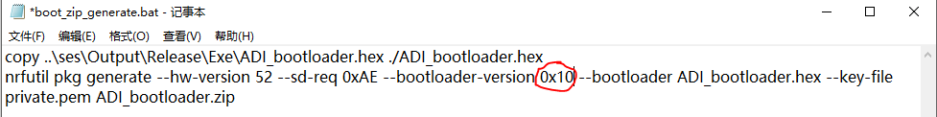

**Note**: The version of bootloader must be greater than the last version, only then the upgrade will be successful. The version of Watch APP must greater than or equal to the last version, only then the upgrade will be successful. The initial version of bootloader and Watch APP is equal to zero.

1. Connect the DVT1 Watch to the PC with USB cable and note down the COM port number shown.
2. Edit “boot_usb_download.bat” from the same path as above, to correct the com port.

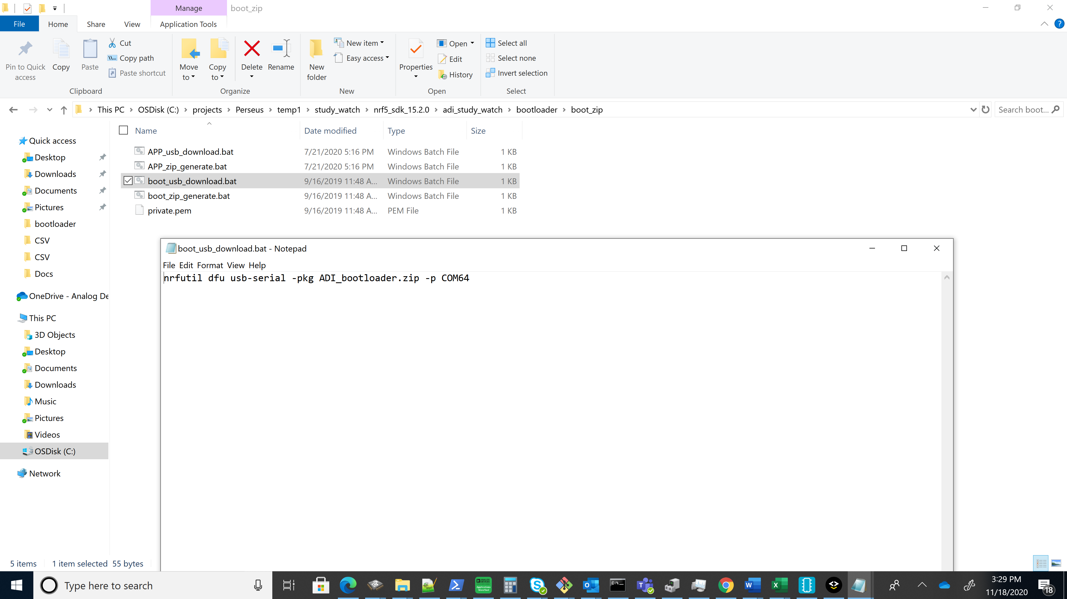

1. Execute boot_usb_download.bat. (if “nrfutil” tool is not installed in your PC, “cmd window” will report an error message. Then you have to install “nrfutil” first before running boot_usb_download.bat, by doing ‘pip install nrfutil’).

## Preparing firmware to be downloaded

1. Open the SES project file from the path “study_watch\nrf5_sdk_15.2.0\adi_study_watch\app\nRF52840_app\ses\ watchv4_nrf52840.emProject” compile and keep the firmware to be downloaded ready.
2. Execute “APP_zip_generate.bat debug” path “study_watch\nrf5_sdk_15.2.0\adi_study_watch\bootloader\boot_zip”.

**Note:** The build mode ‘debug’ or ‘release’ has to be passed as an argument

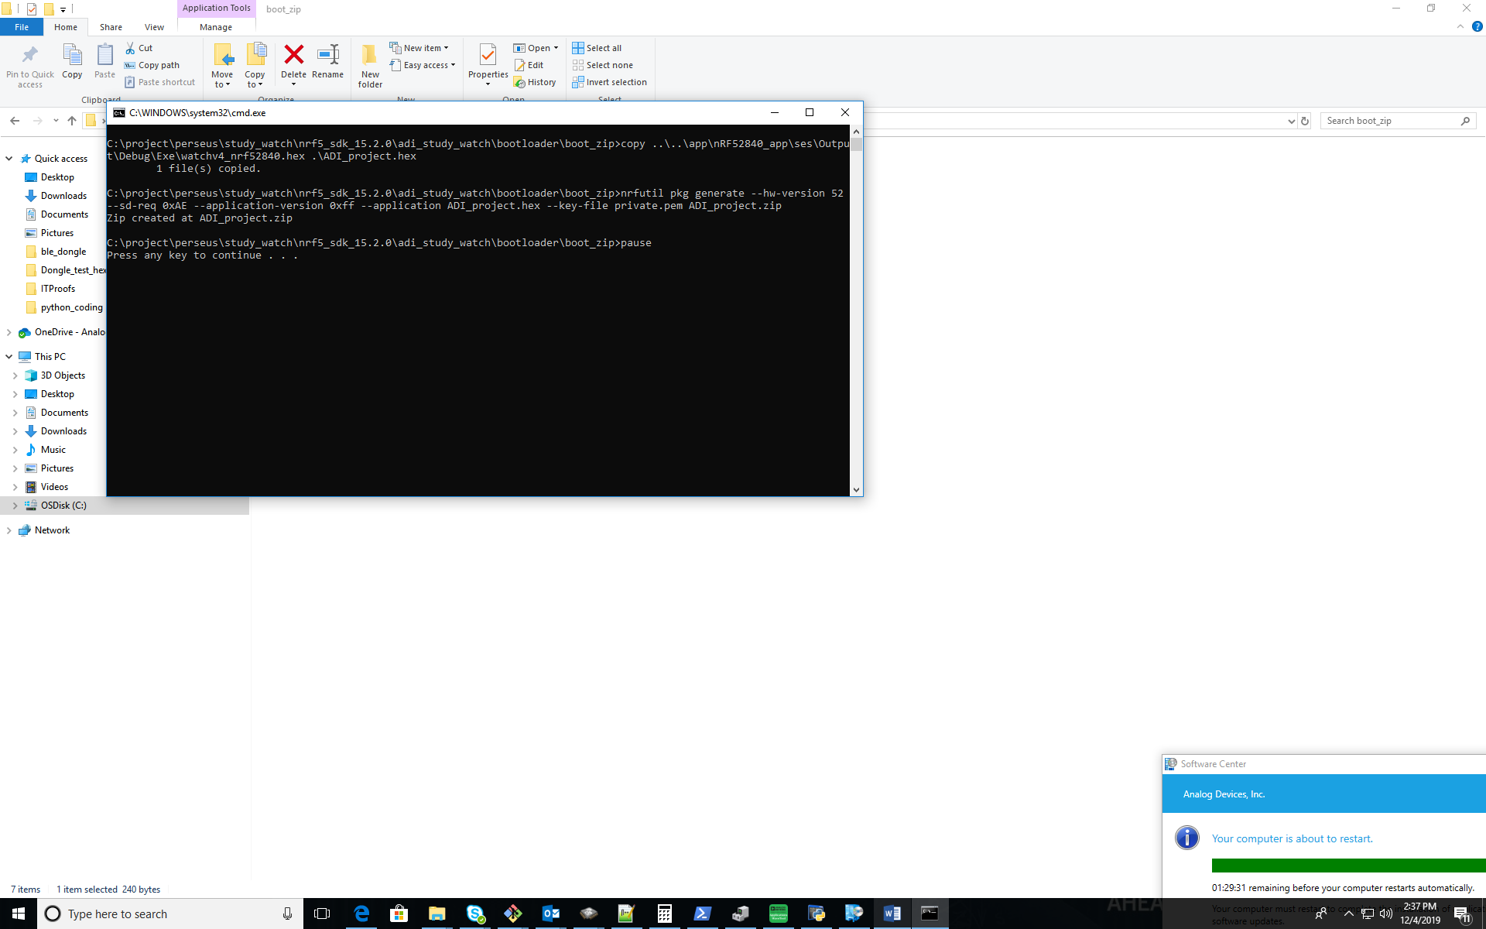

Figure Zip generate screenshot

1. This will generate ADI_project.zip at the end.

## Firmware Upgrade with USB Transport

1. Connect DVT1 Watch with USB cable to the PC and note its com port number.
2. From same path as above, open “APP_usb_download.bat COM30”. (i.e. COMxx) Make this same as what is shown for the DVT1 board currently.

**Note:** The Comport ‘COMxx’ has to be passed as an argument

1. Execute APP_usb_download.bat. (if “nrfutil” tool is not installed in your PC, “cmd window” will report error message. Then you have to install “nrfutil” first before running App_usb_download.bat, by doing ‘pip install nrfutil’).

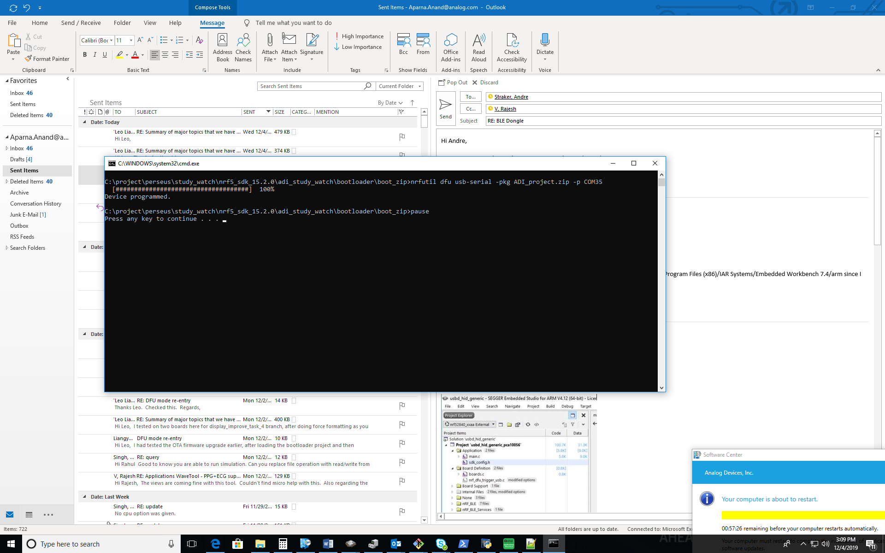

Figure USB DFU screenshot

## Firmware Upgrade with BLE Transport

This section lists down the steps to do Firmware Upgrade on Study Watch via BLE using Android or iOS mobile application.

1. After the USB upgrade is completed, we can test BLE upgrade. Press two buttons on DVT1 board for 5 seconds. This takes it to bootloader stage, and it waits for DFU with “an arrow icon”, as shown in Figure 2
2. The Watch will remain in Bootloader stage for 2 minutes, after which it gets auto cancelled and loads the application image, if present. If, so far the board wasn’t having any application image (1st time firmware upgrade after full Flash erase), Bootloader will just reset and remain in Bootloader stage itself.
3. Move ADI_project.zip file to your phone and open the “nRF connect” mobile app from your phone.

( For details, refer to [https://www.nordicsemi.com/Software-and-Tools/Development-Tools/nRF-Connect-for-mobile](https://mail.fenda.com/owa/redir.aspx?REF=bPDmeRMKsIbIhNqxAMAARJgPdSljw7Y0xFlxm1f7QlgtcqwIgr3WCAFodHRwczovL3d3dy5ub3JkaWNzZW1pLmNvbS9Tb2Z0d2FyZS1hbmQtVG9vbHMvRGV2ZWxvcG1lbnQtVG9vbHMvblJGLUNvbm5lY3QtZm9yLW1vYmlsZQ..) to find out how to install the APP)

1. Scan for the BLE advertisement from the nRF Connect APP. When the APP finds the ADI_dfu, select the CONNECT button to establish the connection.

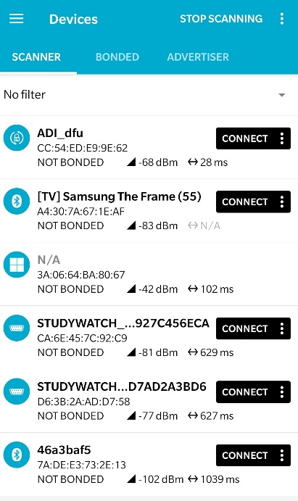

Figure nRF Connect app Scan Results showing "ADI_dfu" device name

1. After it is connected to the DVT1 board, click the “DFU” icon as marked in Figure 6.

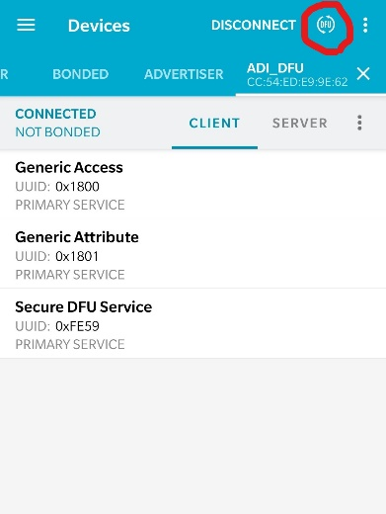

Figure nRF Connect app DFU icon marked

1. A dialog box “Select file type” will pop up, make no change and click “OK” to find the upgrade .zip file from your phone. After the ADI_project.zip file is found, select it and then start the BLE upgrade.

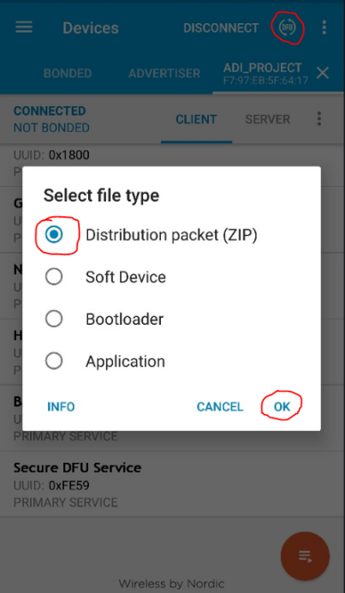

Figure nRF Connect Upgrade zip package selection

1. The Graph showing the transfer details will appear. It is to be noted that, it will take a while to start and complete the transfer – 2-4 minutes. Please wait for the update to complete.

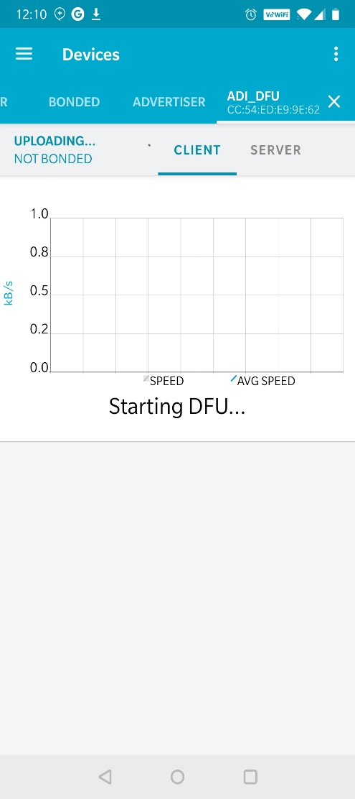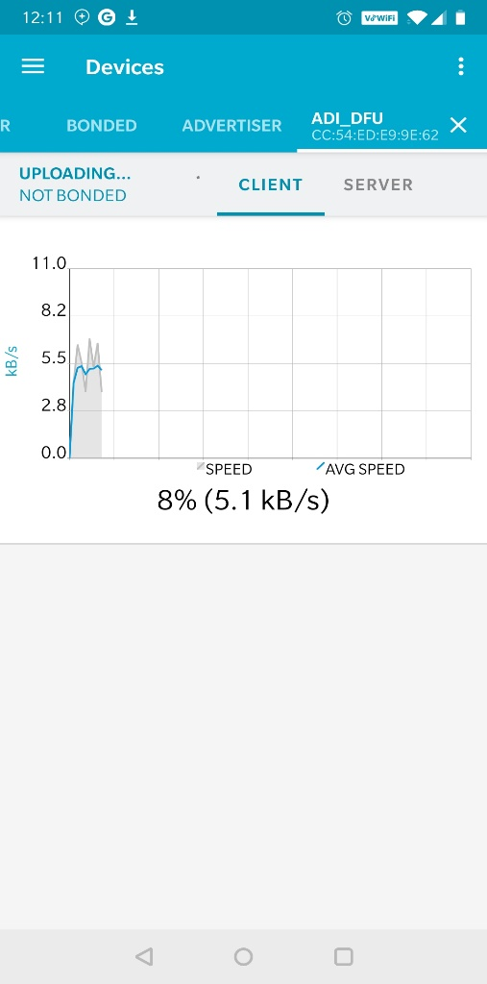

Figure nRF Connect package upgrade status graph

1. After the upgrade process is completed, the APP will automatically close the window and go back to the previous Tab with “ADI_DFU” showing its not connected. This happens because the Watch isn’t in bootloader stage and has a different device name.

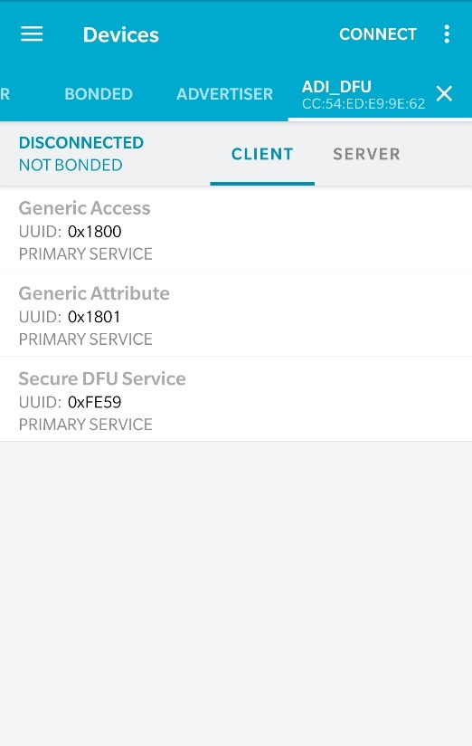

Figure nRF Connect app, after upgrade is completed

1. If you want to test the BLE upgrade again, please return to step 1 above and repeat the process.
2. If you want to test the USB upgrade again, Press two buttons on DVT1 for 5 seconds. This takes it to bootloader stage, and it waits for DFU. And follow steps from the section DFU with USB Transport.

## Firmware Upgrade from Applications Wavetool

1. Prepare and keep the firmware package to be upgraded to following section Preparing firmware to be downloaded:
2. Copy ADI_project.zip to the etc/Firmware path from AWT installation directory as in

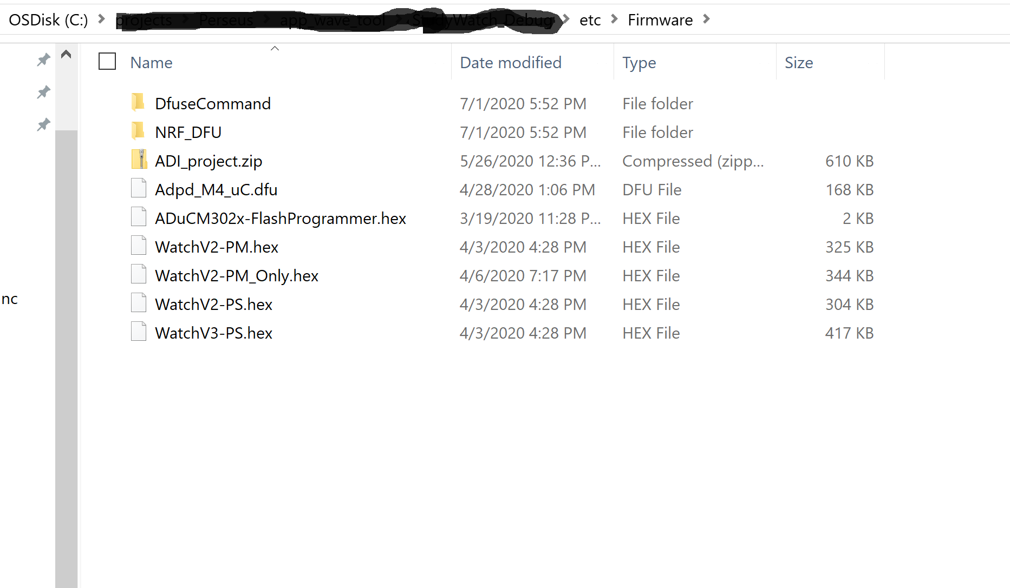

Figure AWT Path to put the upgrade package

1. Connect Watch via USB cable to the PC.
2. Open Applications Wavetool and Click on Firmware Upgrade option as shown in Figure 7

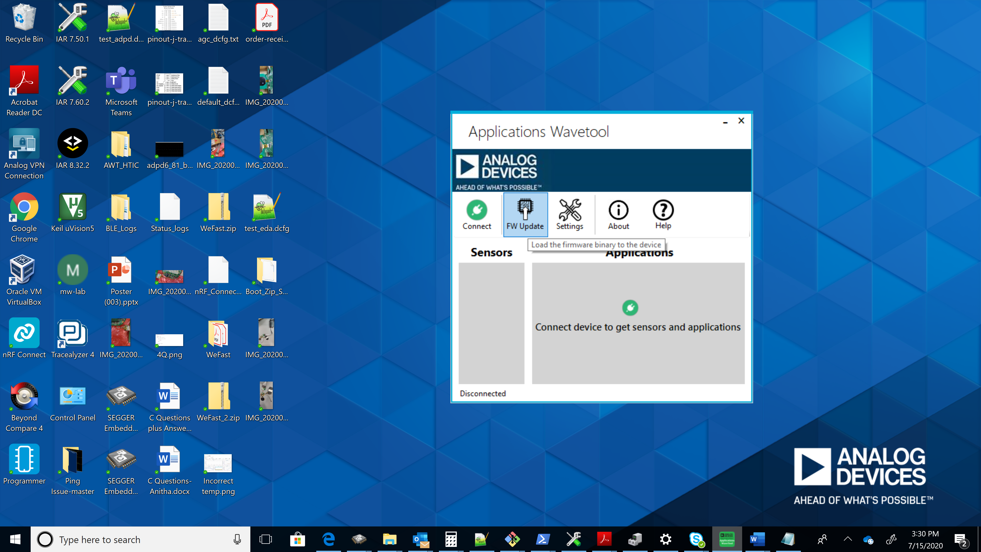

Figure Firmware Upgrade from AWT

1. Select Platform as Perseus, as shown in Figure 8

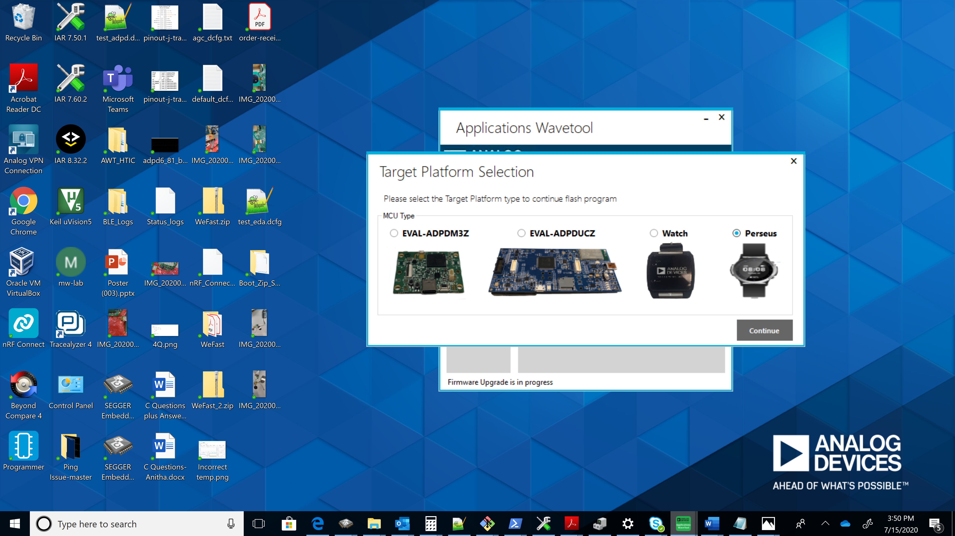

Figure Target Platform Selection

1. Follow the instructions shown in Figure 9

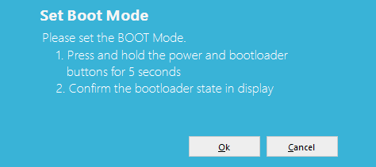

Figure AWT Fw Upgrade instructions

1. At the end of firmware upgrade, Watch would be reset and its ready to be used.